Velammal College of Engineering and Technology, Madurai-625009
(Autonomous)
Department of Computer Science and Engineering
Assignment I

21CS203/OBJECT ORIENTED PROGRAMMING

Content | 14
References | 2
presentations | 2
Timely submission | 2
TOTAL | 20

Course Incharge HoD-CSE

Submitted to:
J.Shanthalakshmi Revathy
Assistant professor
Department of CSE
Velammal College of Engineering and Technology
Madurai-625009

Submitted to:
N.Gowtham Kumar
II-year of cse
CSE-‘B’
21CSE104

QUESTION 1: Relate OOPs concepts with real time Examples:

If you had a class called “Expensive Cars,” it could contain objects like Mercedes, BMW, Toyota, and so on.
There are 4 OOP concepts. They are,
- Objec
2.class
3.Polymorphism
4.Inheritance
5.Encapsulation
6.Abstraction

1. Object
The Object is the real-time entity having some state and behavior. In Java, an Object is an instance of the class having the instance variables like the state of the object and the methods as the behavior of the object. The object of a class can be created by using the new keyword in the Java Programming language.
A class is a template or blueprint from which objects are created. So, an object is the instance(result) of a class.
I found various Object Definitions:
1. An object is a real-world entity.
2. An object is a runtime entity.
3. The object is an entity that has a state and behavior.
4. The object is an instance of a class.

Real-world examples
Dogs have state (name, color, breed, hungry) and behavior (barking, fetching, wagging tail). Chair, Bike, Marker, Pen, Table, Car, Book, Apple, Bag, etc. It can be physical or logical (tangible and intangible)
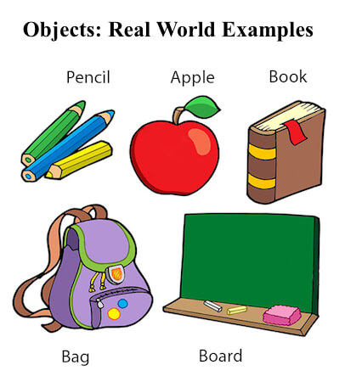
Bicycles also have state (current gear, current pedal cadence, current speed) and behavior (changing gear, changing pedal cadence, applying brakes).
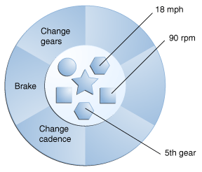

2. Class
A class is a group of objects which have common properties. It is a template or blueprint from which objects are created. In short, a class is the specification or template of an object.
A real-world example is Circle. Let’s look at an example of a class and analyze its various parts in the below diagram. This example declares the class Circle, which has the member variables x, y, and radius of type Integer and the two member-methods, area()and fillColor().
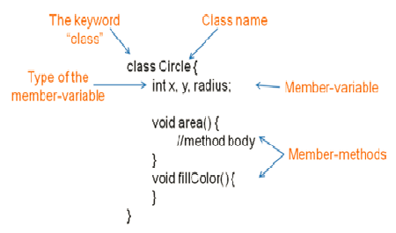

A class is a template for creating objects
Below diagram shows a Circle class which is a template to create three objects:
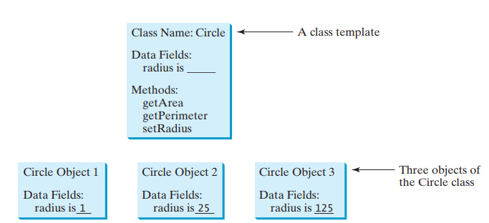

3. Polymorphism
Polymorphism is the ability to exit in many forms.
Example :We can take a boy as a real-world example. This boy can be a student, a player, and a writer. So that this boy can exist in different ways in different situations.
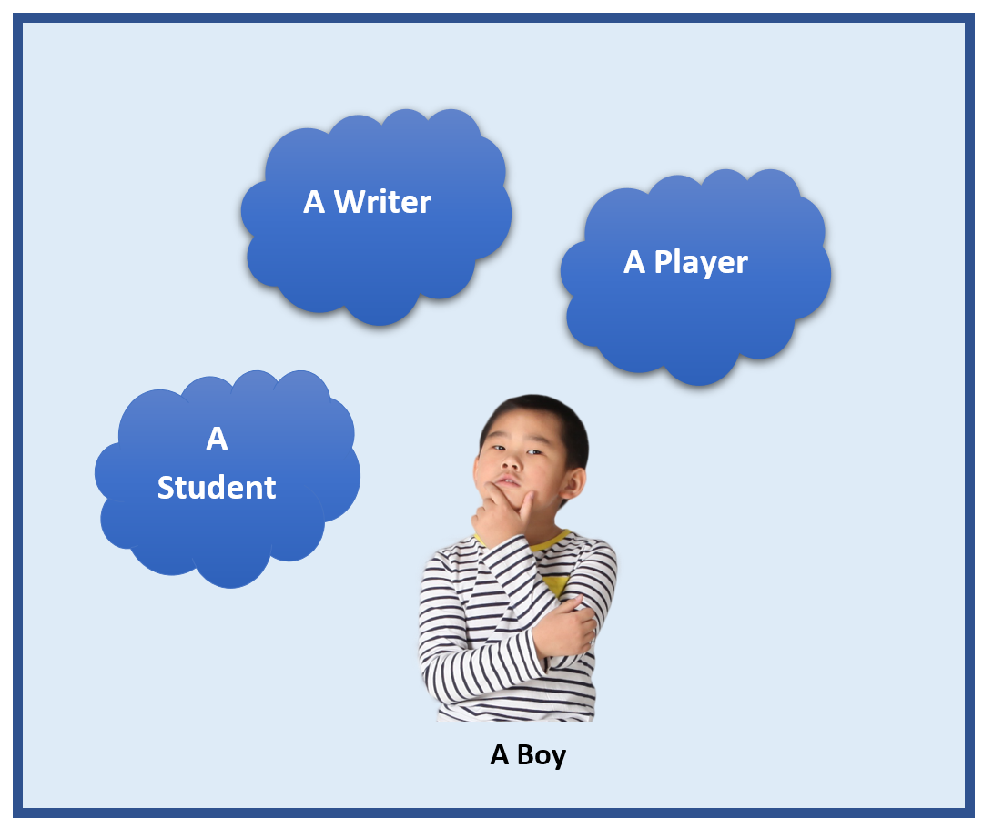

4. Inheritance
Inheritance means it allows classes to inherit common properties from the parent class.

Example: let's assume that there is a class as Vehicle. All vehicles are not the same. We can inherit common properties like color, size, type from the parent vehicle class and create classes like Car, Bus, Bike.


5. Encapsulation
Encapsulation means it binds data and code together into one unit.
Example : the most commonly used example is the medical capsule. This capsule mixes few types of medicines and stored in one capsule.
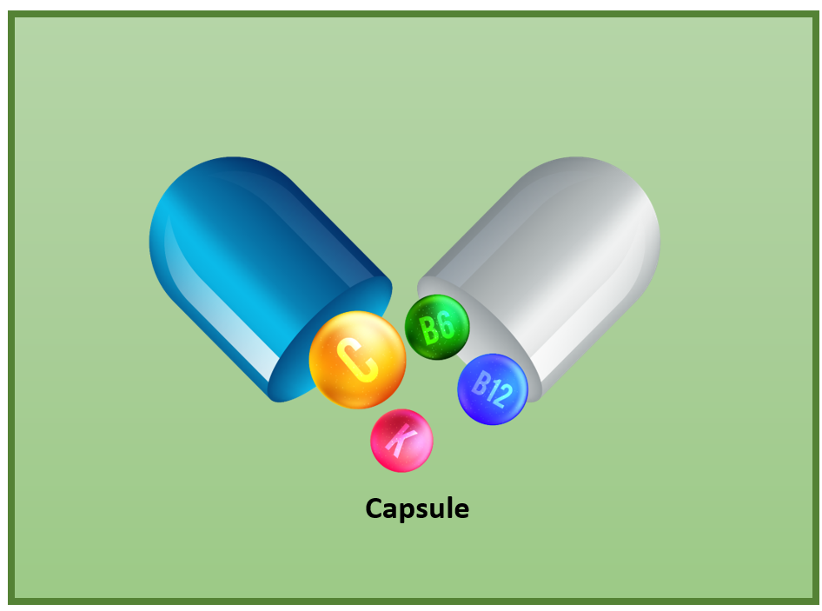

6. Abstraction
In abstraction, it displays only the important information by hiding the implementation part.
Example : Let's take the ATM machine. In an ATM machine, we can perform functions like withdraw cash, deposit cash, check balance, print bills, and so on. Even though it performs a lot of actions it doesn’t show us the process. It has hidden its process by showing only the main things like getting inputs and giving the output.
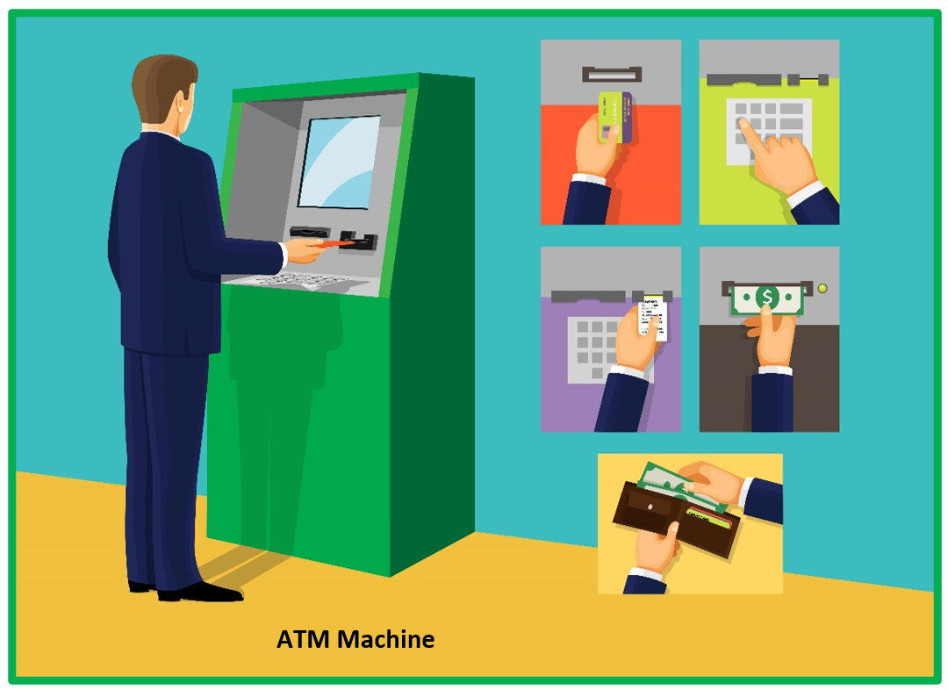

QUESTION 2:What does the framework mean in Java? Explain in detail any one Java Framework:

Java frameworks are bodies of reusable pre-written code acting as templates that developers can use to create applications by filling in custom code as needed. Frameworks are created to be used over and over so that developers can program applications without the manual overhead of creating everything from scratch.

Popular Java Frameworks
Some of the most popular Java frameworks are:
- Spring
- Hibernate
- Grails
- Play
- JavaServer Faces (JSF)
- Google Web Toolkit (GWT)
- Quarkus

Spring
It is a light-weighted, powerful Java application development framework. It is used for JEE. Its other modules are Spring Security, Spring MVC, Spring Batch, Spring ORM, Spring Boot and Spring Cloud etc.
Advantages
- Loose coupling
- Lightweight
- Fast Development
- Powerful abstraction
- Easy to test

Hibernate
Hibernate is ORM (Object-Relation Mapping) framework that allows us establish communication between Java programming language and the RDBMS.
Advantages
- Portability, productivity, maintainability.
- Open source framework.
- It avoids repetitive code from the JDBC API.

Grails
It is a dynamic framework created by using the Groovy programming language. It is an OOPs language. Its purpose is to enhance the productivity. The syntax of Grails is matched with Java and the code is compiled to JVM. It also works with Java, JEE, Spring and Hibernate.
Advantages
- It uses Groovy programming standard instead of Java programming standard because Groovy is similar to Java.
- Its object mapping feature is easy to use.
- It provides the facility of reusing the code (in the form of plugin) between different Grail applications.
- Provides flexible profiles.

Play
It is a unique Java framework because it does not follow JEE standards. It follows MVC architecture pattern. It is used when we want to develop highly scalable Java application. Using Play framework, we can develop lightweight and web-friendly Java application for both mobile and desktop.
Advantages
- No configuration is required.
- It enhances the developer productivity and target the RESTful architectures.
- It offers hot code reload and error message in the browser.
- It also supports popular IDEs.

JavaServer Faces
It stands for JavaServer Faces. It is a component-based UI framework developed by Oracle that is used to build user interfaces for Java-based applications. It follows MVC design pattern. The application developed using JSF has an architecture that defines a distinction
Advantages
- It is an important part of JEE.
- Provides rich libraries.

Google Web Toolkit (GWT)
It is an open-source framework that allows developers to write client-side Java code. With the help of GWT, we can rapidly develop complex browse application. The advantages to use GWT is that we can easily develop and debug Ajax application. the product of Google, such as Google AdSense, Blogger are developed using GWT.
Advantages
- It employs reusability for web application development
- We can use Google API to develop application.
- It provides functionality such as, internationalization, UI abstraction, and history management.

Quarkus
It is a modern, full-stack, and Kubernetes-native Java framework. It offers small memory footprint and reduced boot time. It works well if the infrastructure is cloud-native. It optimizes Java specifically for Kubernetes and enables it to become an effective platform for serverless, cloud, and Kubernetes environments.
Advantages
- It is used in cloud, containers, and serverless environments.
- It supports microservices architecture and development.
- The developers are free to choose own development model.
- It is compatible with popular frameworks like, Eclipse, Spring Dependency Injection, and Hibernate.

Advantages of Java Frameworks
The advantages of the Java Frameworks are as follows:
- Security: It is the most important advantage of the Java framework. If we found any security loop hole or vulnerability in an application, we can directly move to the official website of the framework to fix the security related issues.
- Support: The widely used framework provides large forums or groups where we can put our problem for the solution. It also provides the documentation of the framework that helps us to understand the working of the framework.
- Efficiency: If we are doing a task without using the framework, it may take time to complete. But if we are doing the same work by using the framework, we can complete that task in easy and fast way. Therefore, using the Java framework development become faster, easier and effective. It also saves time and efforts.
- Expenses: Another advantage of using the framework is to reduce the cost of the application. Because the maintenance cost of the framework is low.

Examples of Frameworks in Java
In Java, Collection is an example of the framework. It reduces the programming efforts because it provides useful data structure and algorithms. It is referred to as library that do not provides inversion of control.
Another example of framework is, Swing and AWT classes. Swing is a GUI based framework used to develop windows-based application. It contains a large number of interfaces. There is inversion of control because of listeners.

Framework vs. Library

Library | Framework
Library is the collection of frequently used, pre-compiled classes. | Framework is the collection of libraries.
It is a set of reusable functions used by computer programs. | It is a piece of code that dictates the architecture of your project and aids in programs.
You are in full control when you call a method from a library and the control is then returned. | The code never calls into a framework, instead the framework calls you.
It is in corporate seamlessly into existing projects to add functionality that you can access using an API. | It cannot be seamlessly incorporated into an existing project. Instead it can be used when a new project is started.
They are important in program for linking and binding process. | They provide a standard way to build and deploy applications.
Libraries do no employ an inverted flow of control between itself and its clients. | Framework employs an inverted flow of control between itself and its clients.
Example: jQuery is a JavaScript library that simplifies DOM manipulation. | Example: Angular JS is a JavaScript-based framework for dynamic web applications.

References:
https://www.javatpoint.com/what-is-framework-in-java

https://jeemariyana.medium.com/oop-concepts-with-real-world-examples-cda1cd277f4f

https://www.javaguides.net/2019/08/oops-concepts-in-java-with-realtime-examples.html

